Sudarshan Vidya Mandir Institution

English project

Name: Nathasha.B.Deelok

Class & section: 9B

Topic: “I Remember, I Remember”

Submitted to: Vidya Kamat

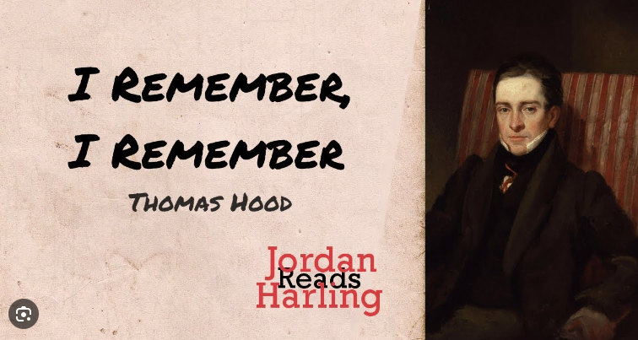

Signature